WISDOM  
HOPE  
COMMUNITY  
DIGNITY  
EQUALITY DIVERSITY



Information pack for candidates

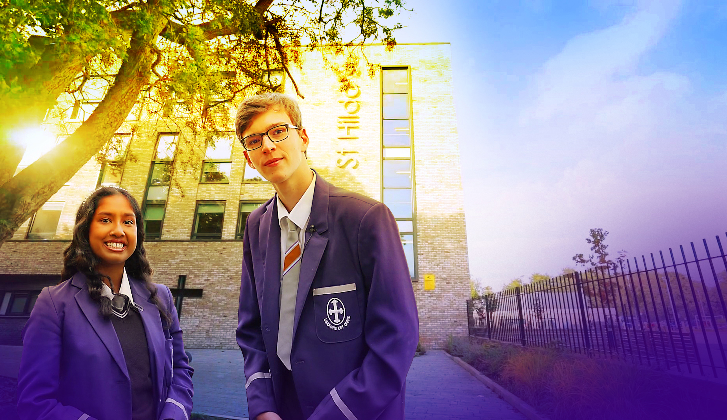

Welcome

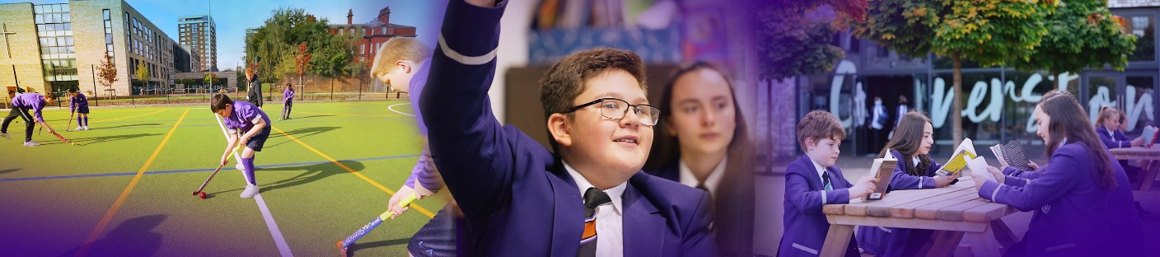

Dear Candidate

Many thanks for your interest in St Hilda's and the post of Head of Physical Education.

St Hilda's is unique. St Hilda’s is a family. We are the only co-educational Church of England school in Liverpool in key stages 3 and 4. We welcome students and their family from a Christian background, from other faiths and those who have no faith. Each individual is precious.

Although our reputation in the community is excellent, this does not mean that we do not look for opportunities to improve who we are and what we do. We live by our values and are educating for 'wisdom, hope, community, dignity, equality and diversity'. Students helped to choose our 6th value of diversity. We changed to a house system to promote a sense of belonging in each of our students and members of staff. Our smaller House families come together to form the larger St Hilda’s family. We chose our 5 Houses very carefully. Each one of these inspirational people embody our values and have helped to shape Liverpool. We speak in more detail about Margaret Aspinall, Gee Walker, Kitty Wilkinson, John Brodie, William Roscoe and Levi Tafari on our website.

We believe in student voice, in student leadership and in high expectations. Our behaviour systems focus on a Chance to Change and we work hard in ensuring we support our students in making the right decisions, ready to take their place in our society. In 2023 SIAMS Keeping On Track report highlighted ' The school’s Christian vision and associated values are at the heart of this church school. The inclusivity and celebration of the diversity of the school’s community ensure that all feel welcome and valued as unique children of God.' We are unashamedly a Christian school. Our most recent Ofsted report graded us as Good in 2021.

We are heavily oversubscribed, but this does not mean that we do not recognise that we can become even better. We are looking for someone who will join the St Hilda's family in the key position as Head of Physical Educationwho champions all of our students, challenges where necessary and celebrates at every opportunity. You will support and develop the people in your team, ensuring all opportunities are taken to lead and share excellent practice. Your vision to support St Hilda's to the next level is paramount.

Academically, St Hilda's intake above is national average. However, our aspiration is that every single one of our students achieves or exceeds their potential, has exceptional pastoral support and has a wealth of opportunities to support their development. In this role, we are looking for a very special person with the vision and experience to help our vision become a reality. Is this you?

We welcome visits from prospective candidates, but this will not form part of the selection process. Please contact Tracey Cain/Jacqueline Draper by email should you wish to arrange a visit [recruitment@st-hildas.co.uk](mailto:recruitment@st-hildas.co.uk)

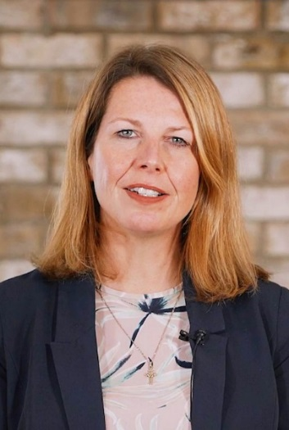I look forward to receiving your application if you believe that St Hilda's suits your career aspirations and you meet our criteria for selection. We are looking for a very special Head of Physical Education, whose vision can take the department to the next level.

Thank you for your time,

**Mrs Jo Code**, Headteacher

St Hilda’s CE High School

St Hilda’s CE School is an 11-18 co-educational Church of England school that sits on the fringe of Sefton Park in Liverpool. The school currently has 1065 Students. Due to parental demand for places at the school, from September 2018 we increased our Year 7 PAN from 150 to 170. We pride ourselves in being a fully inclusive school that serves our Diocese and beyond. Our vision encapsulates who we are as a school:

We are the St Hilda’s family, with Jesus Christ as our cornerstone.   
Building on foundations of **wisdom**, **hope**, **community**, **dignity,** **equality** and **diversity**, we nurture and support each other to be or very best. We rejoice in our diversity and celebrate our many achievements.

St Hilda’s also has a sixth form. St Hilda’s College is an integral part of the school and last year, over 88% of Year 11 chose to continue their education at St Hilda’s. The College is growing year on year.

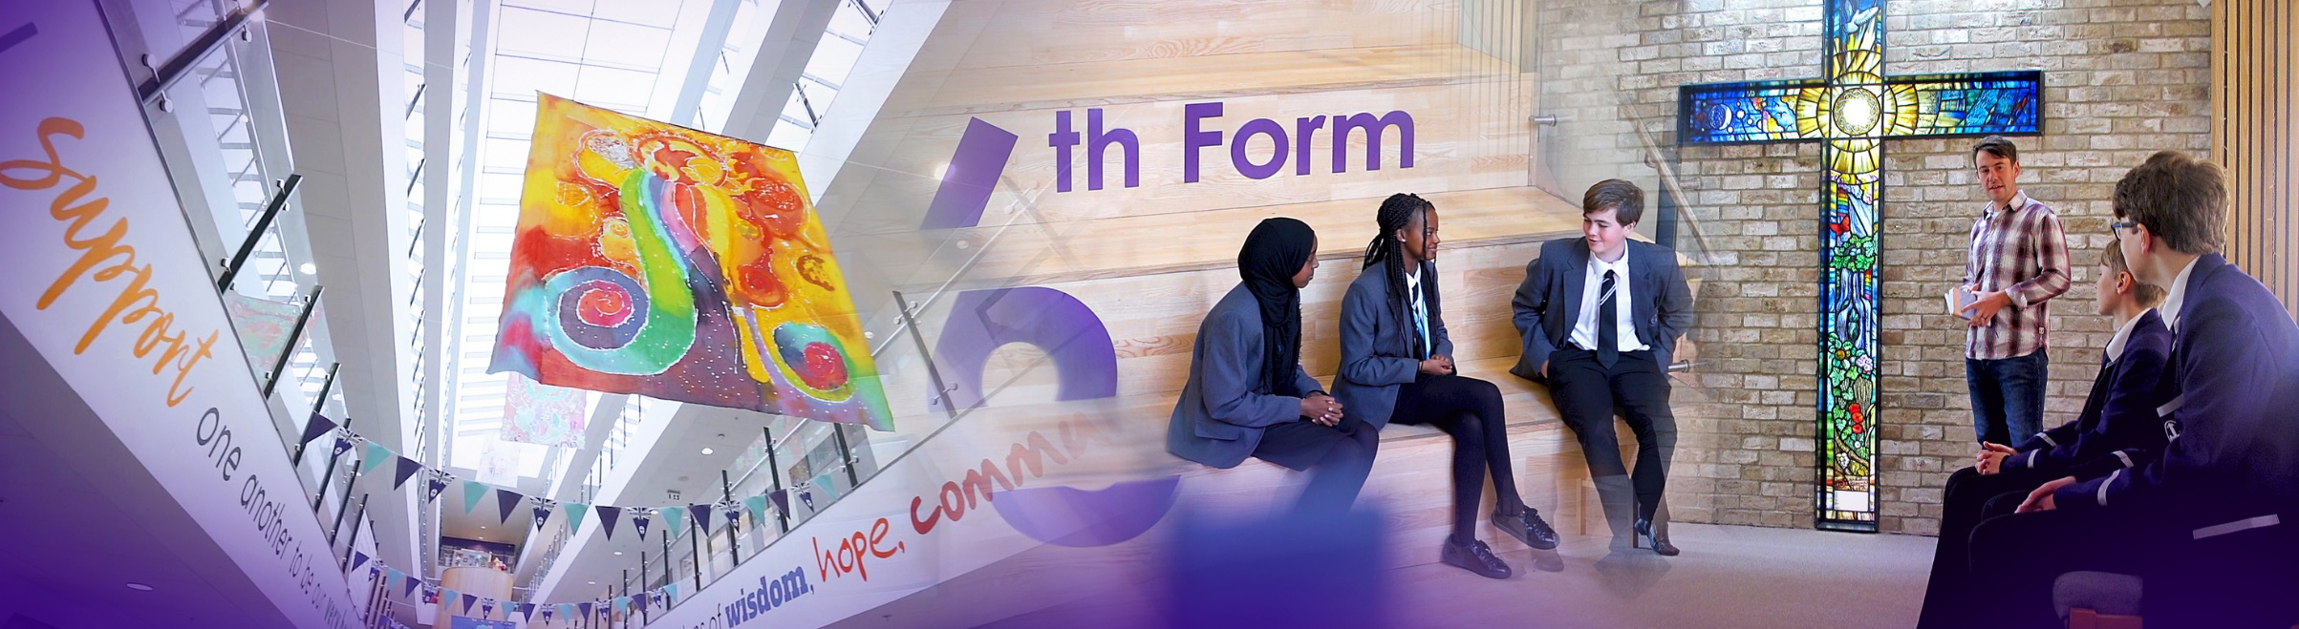

The new school buildings were opened in September 2015. We are incredibly proud of the excellent facilities we have, including excellent sports facilities. St Hilda’s College have dedicated areas in the school, including their own study rooms and café.

Our greatest asset at the school is our staff. St Hilda’s staff are incredibly generous with their time and support of each student. We have an incredibly low turnover of staff and we retain many of our NQTs and former students return to work here.

This is an exciting time to join the school and become part of a hard-working and committed team who embody our vision and values.

_________________________________________________________________________________

Senior Leadership Team

**Jo Code,** Headteacher   
Vision and values, curriculum, data, SEP, SIP, admissions, monitoring and tracking, QA systems policies.

**Karen Kearns,** School Business Manager  
Strategic Finance, Premises; Maintenance, Development and staffing, Health & Safety, School Calendar, Service Contracts and performance, Catering, Lettings.

**Roy Bellmon,** Deputy Headteacher  
St Hilda’s College, IT strategy, Admissions and Appeals, Worship, SIAMS.

**Suzanne Harrison,** Deputy Headteacher  
Behaviour and Inclusion. Deputy DSL, Inclusion, SEND, Attendance, Director of STEM,

**John Martin,** Assistant Headteacher  
Deputy DSL, Behaviour support, Student Welfare, House System, Rewards and celebration, Friends of St Hilda’s, parent engagement, transition.

**Liz Cowdell,** Assistant Headteacher  
Quality of Education, Curriculum, Teaching and Learning. Exams & Assessments KS4, CPD

**Andrea Howard,** Assistant Headteacher  
Head of College, Teaching and Learning KS5, Data, ARR, Examinations and Options.

**Lisa Franks, SENCo**  
SENCo, SEND, Looked after Children Champion, Vaccinations

**Carina Bird,** Assistant Headteacher

Academic Catch-up and Lead T&L Team, Summer School. Quality of Education, PP Champions.

**Conor Merrick,** Associate Assistant Headteacher

Head of English, Literacy and Reading Intervention.

**Ben Norton**,Associate Assistant Headteacher

Early Careers and Appraisals. ECF Lead, ITT Lead.

**_______________________________________________________________________________**

Liverpool

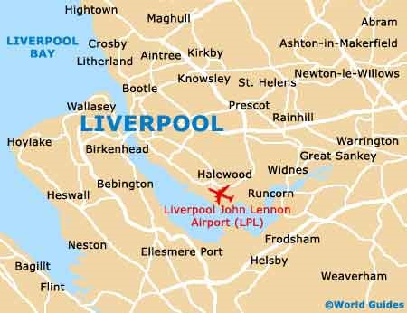Liverpool is a city with unique attractions, exciting events, world class sport offerings, unrivalled musical heritage and a famously warm welcome!  
  
  
**Location and Transport Links**  
Liverpool enjoys superb communication links.   
St Hilda’s CE School is located close to the M62 and other major roads. There are train and bus links to   
St Hilda’s. Liverpool Lime Street train station is the main station serving the city of Liverpool. Liverpool Airport is less than 30 minutes away.

©Marketing Liverpool, Liverpool Docks 2

**Facilities and Amenities**St Hilda’s CE School is close to the 3 universities in Liverpool. We are also close to Liverpool One; a range of shops, bars, restaurants, cafes and a cinema. Speke Retail Park and Edge Lane Retail Park are also close by.

Liverpool has the largest collection of museums and galleries anywhere outside London. The city also has several hospitals, theatres, cinemas and numerous other cultural and leisure facilities. St Hilda’s CE School lies in South Liverpool, overlooking Sefton Park.

**Housing and Accommodation**  
A range of accommodation options are available in the local area and there is a thriving rental market. The excellent transport links allow many staff at the school to live in outside of Liverpool. Help and advice can be given by the school if accommodation is required.

_________________________________________________________________________________

Job Description

Whilst every effort has been made to explain the main responsibilities and duties of the post, each individual task to be undertaken will not be identified. Employees will be expected to comply with any reasonable request from a manager to undertake work of a similar level that is not specified in this job description. The job description is current to the date shown but, in consultation with you, it may be changed by the Headteacher to reflect or anticipate changes in the job commensurate with the grade and Job Title.

Head of Physical Education

|  |  |
| --- | --- |
| Working time: | Full time, permanent |
| Grade: | MPS/UPS plus TLR2c |
| Disclosure level: | Post is subject to a current enhanced disclosure |
| Reporting to: | Headteacher  SLT Line Manager |
| Working with: | Middle Leaders  The PE department  Pastoral support  Data Analyst  Data Officer  Exams Officer |

PURPOSE OF POST

1. To lead a successful department as a dedicated, creative, inspiring and energetic curriculum leader.
2. To lead, develop and improve the quality of education in the PE Department.

2. To lead and be responsible for the quality of Teaching and Learning: including pedagogy,

student progress and outcomes in the PE department.

3. To contribute to St Hilda’s role as a high-achieving school, informed by research and best practice.

5. To actively model and promote the values and ethos of the school.

6. To be accountable for the line-management of staff within the PE department.

7. To actively support the efficient and effective running of the school and good order, welfare, and safety of

students and staff.

GENERIC RESPONSIBILITIES

*Shaping the future: Strategic direction*

1. To ensure outstanding provision in own department.

2. To keep abreast of local, national and global developments in pedagogy and research.

3. To contribute actively to building, communicating and implementing a shared vision of the school’s future.

4. To contribute actively to the strategic planning process.

5. To work with new technologies and help develop their use to promote teaching, learning, the experience of students and the effectiveness of the school.

6. To be accountable for leading and managing change.

7. To demonstrate a commitment to –

1. the collaborative school vision of excellence and equity – high standards / expectations for all

students

b) helping to set and achieve challenging and ambitious targets

c) inclusion.

8. To demonstrate the ability to –

a) think strategically

b) inspire, challenge, motivate and empower others

c) model the values and vision of the school and actively promote our Christian ethos.

9. To show commitment to:

1. raising standards in pursuit of excellence
2. equipping students with the necessary mindset for success; building resilience, ambition, determination and problem-solving
3. the entitlement of all students to the best possible teaching and learning
4. personalised and cooperative learning
5. coaching and mentoring students to ensure maximum commitment and effort.

10. To demonstrate the ability to:

1. demonstrate personal enthusiasm for learning
2. demonstrate the principles and practice of the best teaching and learning
3. challenge poor performance
4. develop relevant strategies for improved performance.

11. Support our 6 values of wisdom, hope, community, dignity, diversity and equality.

12. Be sympathetic to the teachings of the Church of England.

13. Operate at all times within the stated policies and practices of the school.

14. recognise health and safety is a responsibility of every employee, to take reasonable care of self and others and to comply with the school’s Health and Safety policy.

15. promote the welfare of children and to support the school in safeguarding children though relevant policies and procedures. Establish a purposeful and safe learning environment which complies with current legal requirements, national policies and guidance on the safeguarding and well-being of children and young people so that learners feel secure and sufficiently confident to make an active contribution to learning and to the school.

SPECIFIC RESPONSIBILITIES

1. To lead and have responsibility for PE at the school; for the quality of PE teaching, for results of assessments and standard of marking, recording and reporting of students’ work.
2. To provide regular information to members of SLT in relation to PE.
3. To monitor, evaluate and act upon students’ progress, achievement and attainment in all PE key stages.
4. To liaise with other PE members of staff to identify under performance by students and ensure appropriate intervention strategies and plans are implemented.
5. To liaise with other PE members of staff to ensure continuity and progression of achievement and attainment.
6. To develop assessments and marking which promote student progress and support teacher workload and work-life balance.
7. To co-ordinate and oversee the work of other teachers in relation to the development and delivery of PE.
8. To conduct observations and use the knowledge gained to improve the quality of Teaching and Learning within the department, learning from each other.
9. To ensure the professional development of all members in the PE, helping them to set relevant targets to support the department and school improvement plans.
10. To model appropriate teaching strategies and lessons for others to observe, using department time to share the most effective practice.
11. To teach Good or better PE lessons at all key stages 3, 4, and 5.
12. To have the highest standards within the PE department, using the school’s behaviour and rewards systems to develop good relationships.
13. To ensure that home learning is effective and underpins the schemes of learning and student progress.
14. To use current research to impact the effectiveness of the department and to produce the best results and life-long learning for all
15. To actively lead the promotion of PE careers, working collaboratively with key departments involved in STEAM School.

Whilst every effort has been made to set out the main duties and responsibilities of the post, each individual task undertaken may not be identified. All staff may be required to undertake other such reasonable duties as may be required in line with the grade of this post.

**This job description is a guide to the duties and should be read in conjunction with the accompanying person specification.**

**This post is subject to an enhanced DBS disclosure check through the Disclosure & Barring Service**

**In your letter of application, please  *demonstrate* how you meet these criteria.**

**Do not include a curriculum vitae.**

**Candidates failing to meet any of the essential criteria will automatically be excluded.**

**[A]**

|  |  |  |  |
| --- | --- | --- | --- |
| Qualification requirements | Essential | Desirable | Source |
| Qualified teacher status | E |  | A |
| Recognised degree or equivalent in Physical Education or related subject | E |  | A |
| Further professional development: post-entry qualification |  | D | A |

1. **Experience**

|  |  |  |  |
| --- | --- | --- | --- |
|  | Essential | Desirable | Source |
| At least four years’ teaching experience | E |  | A/I/R |
| Teaching experience in more than one secondary school |  | D | A/I |
| Track record of successful team leadership which has improved outcomes for students |  | D | A/I/R |
| Middle Leader Responsibility |  | D | A/I/R |
| Whole-school development responsibility |  | D | A/I/R |
| Evidence of successful student achievement | E |  | A/I/R |
| Experience of experience of having designed, implemented and  evaluated impactful schemes of learning. | E |  | A/I/R |

1. **Knowledge/Understanding**

|  |  |  |  |
| --- | --- | --- | --- |
|  | Essential | Desirable | Source |
| Outstanding practitioner in own subject area, as evidence by student progress/outcomes/performance feedback. | E |  | A/I/R |
| Ability to teach PE to A-Level |  | D | A/I/R |
| Knowledgeable about best practice in Teaching and Learning, pedagogy, and developing staff. | E |  | A/I |
| Data-smart with the ability to use data analysis to improve progress and outcomes for students across all 3 key stages | E |  | A/I |
| Mastery of and enthusiasm for PE | E |  | A/I/R |
| Recent professional development/INSET relevant to the post | E |  | A/I |
| Knowledge of the primary/secondary education system, examinations and curriculum | E |  | A/I |
| Leadership and Management training |  | D | A/I |
| Knowledge of supporting staff and championing their professional development | E |  | A/I |

1. **Personal Qualities and Skills**

|  |  |  |  |
| --- | --- | --- | --- |
|  | Essential | Desirable | Source |
| Outstanding communicator | E |  | A/I |
| Outstanding interpersonal skills | E |  | A/I |
| An excellent networker – receptive, flexible and persuasive | E |  | A/I |
| Team player – empathetic to the needs of the department, able to challenge and support | E |  | A/I |
| Strategic, able to balance long-term and short-term goals | E |  | A/I |
| Ability to motivate | E |  | A/I |
| Ability to meet deadlines/manage time | E |  | A/I |
| Resilient | E |  | A/I |
| ICT literate | E |  | A/I |
| Commitment to the school Christian values and vision | E |  | A/I |

1. **Pre-Employment Checks**

|  |  |  |  |
| --- | --- | --- | --- |
|  | Essential | Desirable | Source |
| Positive recommendation from all referees, including current employer | E |  | R |
| DBS Clearance post appointment | E |  | N/A |

*(Source: A=Application (form+letter); I=Interview; R=Reference)*

1. **Application Form and Supporting Statement**

The form must be fully completed and legible.

The supporting statement should be clear, concise and related to the specific post. No more than 2 sides of A4, font size 12.

There should be no unexplained gaps in career history.

How to apply and the Selection Process

**Deadline for applications: 9.00am Monday 29th April 2024**

Applications should be sent to: [recruitment@st-hildas.co.uk](mailto:recruitment@st-hildas.co.uk)

All candidates, both those shortlisted and those who are not successful, will be contacted by email. Details of the date and time of final interviews will be given to successful candidates. Candidates will also be given a topic to prepare for their lesson observation prior to interview.

__________________________________________________________________________________

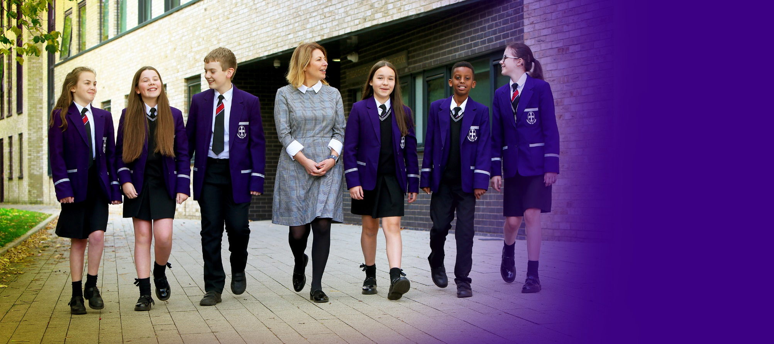

**St Hilda’s CE High School**

Croxteth Drive, Sefton Park, Liverpool L17 3AL

T: 0151 733 2709 E: info@st-hildas.co.uk I: www.st-hildas.co.uk

**Mrs J Code**  
BA (Hons), NPQH, FCCT

Headteacher

WISDOM  
HOPE  
COMMUNITY  
DIGNITY  
EQUALITY

